# **Validation Report Cost-Obj**

## *Summary Report*

*OBJECT*

IfcSlab.BASESLAB

GlobalId: 1r$l67n5fDrxE0IVJzq9nz

Obj Name: Platea:FND_MGR_10:242936

*COST ITEM*

IfcCostItem

Price List Code: LP.EEA.a04.A1020.Qa000.0000.-

GlobalId: 2plZtJIVb2E8V8KIBJo$HV

Cost Name: Wood formwork for foundation

*CHART*

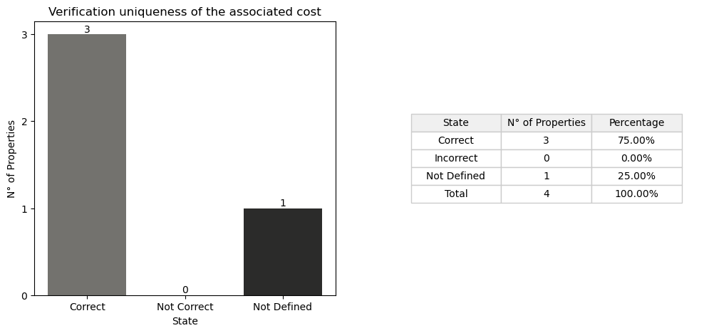

## *Detail Table*

|  |  |  |
| --- | --- | --- |
| **State** | **N° of Properties** | **Properties** |
| Correct | 3 | Entity TypeEnum ConstructionMethod |
| Incorrect | 0 |  |
| Not Defined in the obj | 1 | Status |
| Not Defined in the cost | 0 |  |
| Not Defined in the cost and obj | 0 |  |

## *Detail Report*

**🔸Number of Correct Properties: 3**

Entity: ✓   
 • IfcSlab  
  
TypeEnum: ✓   
 • #4334=IfcSlab('1r$l67n5fDrxE0IVJzq9nz',#21,'Platea:FND_MGR_10:242936',$,'Platea:FND_MGR_10',#4321,#4333,'242936',.BASESLAB.)  
  
ConstructionMethod: ✓   
 • In Situ

**🔸Number of Incorrect Properties: 0**

**🔸Number of Not Defined Properties in Obj: 1**

Status: ✗   
 • property not found in OBJ

**🔸Number of Not Defined Properties in Cost Item: 0**

**🔸Number of Not Defined Properties in Cost Item and Obj: 0**